**Cake Mix Holiday Cookies**

PREP TIME30 Min

TOTAL TIME 50 Min

SERVES 38

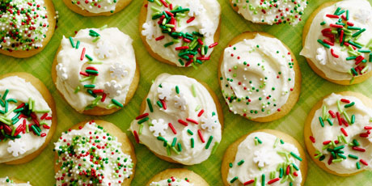

These soft and tender cookies are made with cake mix and topped with a white chocolate-cream cheese frosting, so it's no surprise that they look and taste just like little cupcake tops.

**INGREDIENTS**

**Cookies**

Nonstick cooking spray, for spraying the baking sheets

1 box yellow cake mix (for two 9-inch rounds), such as Duncan Hines

4 Tbsp unsalted butter, melted

2 large eggs

**Frosting**

6 Tbsp unsalted butter

4 oz white chocolate, coarsely chopped

1 (8-oz) pkg cream cheese, at room temperature

½ cup confectioners' sugar

1 tsp pure vanilla extract

Sprinkles, for decorating

**DIRECTIONS**

**Cookies**

1. Position oven racks in the top and bottom thirds of the oven and preheat to 350ºF. Coat 2 baking sheets with cooking spray.

2. Beat the cake mix, butter, eggs and 1/3 cup water with an electric mixer on medium speed in a large bowl until smooth and no bits of dry cake mix are left. Drop the batter by the tablespoonful (a small ice cream scoop will make this task easier) onto the prepared baking sheets about 1 1/2 inches apart. (You will have additional batter for a second batch.)

3. Bake until the cookies are set around the edges but still soft in the center, about 8 minutes. Let the cookies cool on the baking sheets for 10 minutes, then transfer them to a wire rack to cool completely (the rounded tops will sink slightly). When the baking sheets are cool, repeat with the remaining batter.

**Frosting**

1. Melt the butter and chocolate in a medium microwavable bowl in the microwave in 1-minute increments, stirring in between, until smooth.

2. Beat the cream cheese, confectioners' sugar and vanilla together with an electric mixer on medium speed in a large bowl until smooth. Pour the chocolate mixture into the cream cheese mixture and beat until smooth.

3. Frost the cookies, decorate with sprinkles and serve.